***Week 16: April 29-May 2***

***May 2, 2025***

1. Get out the item you brought for the party
2. Determine if you are doing the video extra credit
3. Get your nutrition card from blue counter and review the expectations for the video
4. Wait for further instructions
5. If you should answer the questions, you should begin (everyone except the garden project students: see the chart further down the page if you do not know)

**🍲 Spicy Bowl Party Challenge Assignment & - Extra Credit**

**📋 Assignment Overview**

You're invited to create your own *spicy bowl* and share its nutritional value! During our upcoming *Spicy Bowl Party*, you can earn extra credit by preparing a spicy bowl, completing a Health Card, and optionally presenting your creation in a short video (the video will count as extra credit and must meet the criteria provided in the rubric). Let's explore how food can be both delicious and nutritious!

**PART A. DUE April 30th**

1. **List the item that you will bring to the party for the spicy bowls on Coach Thomas’ List**
2. **Health Card Requirements (Written Assignment)-Your card can not be the same as any of your friends in this class (aside from the ingredients)**

Each student must turn in a one-page Health Card that includes the following:

1. **Ingredients List** – All items in your spicy bowl (e.g., pickled cucumbers, hot chips, peppers, fruit roll-ups, chamoy, etc.)
2. **Nutritional Value (For at least 3 of your ingredients, complete this)** – Identify and explain:
   * Two vitamin-specific benefit towards to the body
   * Two mineral-benefit/function in the body specific to the mineral
   * One macronutrient and its benefit
3. **Healthier Snack Modifications (List 2)** – Explain how your spicy bowl could be made healthier: with each option
   * Example 1: Use baked chips instead of fried ones.
   * Example 2: Swap sugar-heavy candy for dried fruit.

**🎥 PART B: Video Presentation (Optional for Extra Credit): DUE May 2, 2025**

Create a short (1–2 minute) video showing:

* Your spicy bowl and ingredients
* A quick breakdown of your HealthCard facts

**PART C. DUE MAY 7TH 🍲 Spicy Bowl Party Health Handout & Student Questions**

**📘 Informational Reading: Spicy but Smart – Making Snacks Healthier**

**Spicy bowls** have become a flavorful and trendy snack among teens. These bowls often include ingredients like hot chips, pickled vegetables, spicy candies, peppermints, chamoy, and sometimes fruit roll-ups. While spicy bowls are fun to eat and full of bold flavors, they often contain high amounts of **sodium**, **added sugar**, and **unhealthy fats** when eaten in large amounts or too frequently.

But what if we could enjoy these snacks while also making healthier choices?

To understand how to snack smart, we need to know about **nutrients**—substances in food that help our bodies grow, stay strong, and work properly. Three important types of nutrients are **vitamins**, **minerals**, and **fiber**.

**🥦 What Are Vitamins?**

**Vitamins** are natural substances found in foods that your body needs to function well. They help boost your immune system, heal wounds, and convert food into energy. For example:

* **Vitamin C**, found in fruits like oranges and strawberries, helps your body fight off illness.
* **Vitamin A**, found in carrots and sweet potatoes, supports your vision and skin health.

**🧂 What Are Minerals?**

**Minerals** are elements from the earth that your body needs to stay healthy. They help build bones, regulate your heartbeat, and keep your muscles working. Some key minerals include:

* **Calcium**, which strengthens bones and teeth.
* **Iron**, which helps carry oxygen in your blood.
* **Potassium**, which helps muscles contract and keeps your heartbeat steady

**🌽 What Is Fiber?**

**Fiber** is a type of carbohydrate that your body can’t fully digest. It’s found in plant-based foods like fruits, vegetables, whole grains, and beans. Fiber helps keep your digestion regular, prevents constipation, and makes you feel full longer. Eating fiber-rich foods can also help reduce the risk of heart disease and help maintain a healthy weight.

**🔄 Making Spicy Bowls Healthier**

It’s possible to enjoy spicy bowls and still make health-conscious choices. Here are two easy ways to do that:

* **Swap fried chips for baked or whole grain chips**, which have less fat and more nutrients.
* **Replace candy with dried fruit** like mango or pineapple, which still offers sweetness but adds fiber and vitamins.

By understanding what’s in your snack and making smart ingredient swaps, you can enjoy your favorite treats while also supporting your health.

**🎯 Learning Targets**

* I can identify the nutritional value of common snack ingredients.
* I can evaluate ways to improve the healthiness of a popular food trend.
* I can communicate ideas about healthy eating in writing.

**✅ Success Criteria**

* I understand how different ingredients affect health.
* I can give examples of vitamins, minerals, and macronutrients in snacks.
* I can explain ways to make a snack like a spicy bowl healthier.

**📚 Georgia Standards of Excellence – High School Health**

* **HE1.1**: Comprehend concepts related to health promotion and disease prevention.
  + Analyze the relationship between healthy behaviors and personal health.
  + Describe ways to reduce or prevent health problems.
* **HE7.1**: Demonstrate the ability to practice health-enhancing behaviors and avoid health risks.

**✍️Part C. (NOT FOR GARDEN PROJECT STUDENTS) Answer the Questions Below writing the question and answer in your notebook and/or restating the question in your answer-upload image of completed assignment in Canvas and also turn in notebook. (Use complete sentences!): DUE May 7th 2025 (4 questions per day)**

1. What is a spicy bowl, and why is it popular among teens?
2. List three common ingredients found in spicy bowls.
3. What are two nutritional concerns with eating spicy bowls too often?
4. What is one vitamin mentioned in the reading, and what does it do for the body?
5. What is one mineral mentioned in the reading, and what does it do for the body?
6. Define “fiber” and explain how it helps your body.
7. How does eating fiber-rich foods help prevent health problems?
8. Give one example of a healthier chip option you could use in a spicy bowl.
9. Why might dried fruit be a better snack than candy?
10. What is one way you personally could make your spicy bowl healthier?
11. How can reading nutrition labels help you make smarter food choices?
12. Why is it important to understand what’s in the foods you eat, especially snacks?

***Week 15: April 21, 2025-25***

***April 22-25, 2025***

1. ***Get with your group members***
   1. ***Take care of your plant using the chart, your care card, and research as a guide***
   2. ***Consider the following***
      1. ***Has your plant sprouted and if so what is important now to support growth***
      2. ***If your plant has not grown, what can be done to ensure that it does***
2. ***Upload your chart & images including your group member’s names: to the padlet link and Canvas below under Tuesday: you should have data from Thursday, Monday, and Tuesday (2nd period) & Thursday (4th period)***

[***https://padlet.com/thomada/planting-tracking-log-az0x8lce7wn951pf***](https://padlet.com/thomada/planting-tracking-log-az0x8lce7wn951pf)

***April 21***

***Read the chart below and look for your name, if you name is under the writing assignment column, you will complete the notebook assignments moving forward using this same document. If your name is under the Garden column, you will use the chart from the previous week to care for your plant along with instructions from Coach.***

|  |  |
| --- | --- |
| **Health Class Student Assignment Columns from April 21th -May 16th** | |
| **4th Garden** | **4th Writing Assignment** |
| Ny’Asia | Nichi |
| Elijah | Michael? |
| Hannah? | Ian |
| Jalee | Johnny |
| Jayden | Unique |
| Cassidy | Jaelynn |
| Lyric | Ariana |
| Mariah | Ry’ana |
| Darius | Jazmine |
| Scott | Maliyah |
| Bre’anna | Janiya |
|  | Brycen |
|  | Zion |
|  | DiMitrius |
|  | Jamere |
|  | Damion |
|  | Danielle |

***Complete this assignment in your notebook being sure to label each day, provide headings, number the questions, and follow instructions for full credit. All assignments should be on 2-3 pages consecutively. First Aid Week’s Assignments.***

**Monday-April 21: Day 1: Health Discussion (20 points)**

* **Discussion Question:** Answer the following using at least 5-7 complete sentences. Include the answer to each question in your short paragraph. Why is it important to know how to provide basic first aid?
* Think about a time you or someone you know was injured. What happened? What could have helped in that situation?

**Tuesday-April 22: Day 2: Reading Handout & Questions (25 points)**

* Handout: "The Basics of First Aid"

**Reading Material:** First aid is the initial help given to someone who is injured or suddenly becomes ill. It includes simple techniques like cleaning a cut, stopping bleeding, or helping someone who is choking. In any emergency, the first step is to stay calm and ensure the scene is safe. If the injury is serious, you should call 911 immediately. For cuts and scrapes, wash the area with clean water, apply pressure if there is bleeding, and use a bandage. Burns should be cooled with running water, then covered with a sterile cloth. If someone may have broken a bone, do not move them unless necessary—support the injured area and wait for help. CPR (Cardiopulmonary Resuscitation) is used when someone’s heart stops; knowing how to do chest compressions and rescue breaths can save lives.

**Basic First Aid Questions**

Instructions: Read the information above and use it to answer the following questions. For FULL CREDIT, write the question and answer or restate the question in your answer.

1. What are the first steps you should take when someone is unconscious?
2. When should you call 911?
3. Why is it important not to move someone with a potential neck injury?
4. What is the difference between a sprain and a fracture?
5. Multiple-choice questions reviewing key vocabulary and scenarios.

**Wednesday-April 23: Day 3: Scenario-Based Assignment (20 points)**

* Students will read the following real-life scenarios:
  1. *Scenario 1:* You’re at gym class and a student falls and cannot stand due to ankle pain and swelling.
  2. *Scenario 2:* You’re home alone with a sibling who accidentally touches a hot stove and has a red, blistered burn.
* Students must:
  1. Identify the type of first aid needed.
  2. List steps to take to help the person.
  3. Explain why each step is necessary.

**Thursday-April 24: Day 4: Relating to Personal Life (15 points)**

* Journal Prompt: Think about a place where you spend a lot of time (home, school, a sports field). What kind of injuries could happen there? What supplies would you need in a first aid kit for that location?
* Write a paragraph explaining how being prepared can make a difference.

**Thursday-April 24: Day 4: Summary Assessment and Review (20 points)**

* Students will write a summary of what they learned this week about first aid (minimum one paragraph).
* Include one new thing they learned, one thing they found interesting, and one thing they want to remember.

***Week 14: April 14-18***

1. ***Fill in the chart from here moving forward-you can have one chart per group but each person should have access and a copy of the chart: Upload in padlet once complete***
2. ***Padlet:*** [***https://padlet.com/thomada/weekly-schedule-az0x8lce7wn951pf***](https://padlet.com/thomada/weekly-schedule-az0x8lce7wn951pf)

|  |  |  |  |  |  |  |  |
| --- | --- | --- | --- | --- | --- | --- | --- |
| Plant Care Daily Tracking Log: For each of the following analyze your plant and determine what your plant/seed need to support growth. Include detailed information that will be used for collecting data and creating charts in the results section of your lab report. | | | | | | | |
| Date | Water  (how much? ml or oz) | Experimental  Variable (Quantity) | Light | Measurements  Height | Measurement width | Leaf Quantity | Qualitative Observations  -color changes  -flowering (are there flowers & appearance changed)  -new growth  -overall health (signs of disease and/or pest) |
|  |  |  |  |  |  |  |  |
|  |  |  |  |  |  |  |  |
|  |  |  |  |  |  |  |  |
|  |  |  |  |  |  |  |  |
|  |  |  |  |  |  |  |  |
|  |  |  |  |  |  |  |  |
|  |  |  |  |  |  |  |  |
|  |  |  |  |  |  |  |  |

Tuesday-Thursday : 4/15/25-4/17/25

Complete missing work/students informed those that have not completed lab report 1-4 at this point will have different assignments moving forward and will still be responsible for the previous work but will not be able to continue the garden project

***Week 13: March 31-April 4: Read Rubric & Follow instructions to begin project***

|  |  |  |
| --- | --- | --- |
| ***Garden & Nutrition Project:***  ***You can do this with your same group members or as an individual: Option for project are: Canva, poster board, google slides, and other options that have to be approved prior (I am not accepting PowerPoint since students seem to understand PowerPoint and one goal is to ensure you are well rounded regarding various resources available to you): You can use the textbook ch.8 for assistance*** | | |
| *Criteria/Requirements* | *Possible Points* | *Earned Points* |
| 1. *Define nutrition in your own words and explain what nutrients are: DUE March 31* |  |  |
| 1. *List the different types of nutrients including the following for each*   *a.at least three sources b. different types c.specific function in body*  *DUE March 31* |  |  |
| 1. *Pick three different seed that are available for us to plant (based on what coach provided including your seed you planted and the companion seeds you researched for your seed) For each one complete the following*   *a. list the seed*  *b. list the nutrients that it provides (specific to vitamins and minerals)*  *c. describe in your own words the function of the mineral for the body*  *DUE March 31* |  |  |
| 1. *What are 3 cons with eating packaged and store-bought foods based on your textbook in chapter 8 :DUE April 1* |  |  |
| 1. *Create a meal plan for a week including a least three recipes that include the seeds (3) listed from section 3 (for each day you must include, breakfast, lunch, and dinner (make sure your meals are balanced based on the Choose MyPlate. Gov information*   *DUE April 1* |  |  |
| 1. *For the food item (one per group member) you eat the most, include the nutrition label and highlight the following*   *a.serving size*  *b.calories per serving*  *c.total calories for pack*  *d.Fat, sodium, protein, vitamins, and minerals*  *DUE April 2* |  |  |
| 1. *In essay form at least two paragraphs of four complete sentences, explain how this project relates to our horticulture/garden project. Provide details of the*   *benefits of being able to grow your own foods as it relates to your overall health. DUE April 2* |  |  |
| 1. *At least four relevant images April 2* |  |  |
| 1. *Your project should be well organized with headings, subheadings, titles for information being presented (as typically expected of assignments) DUE: March 31-April 2* |  |  |
| 1. *Recorded or In person Presentation DUE April 3* |  |  |
| *Total* |  |  |

***Week 12: March 24-March 28***

**Friday: March 28th**

**March 28th Assignment: The Connection Between Growing Your Own Food & Nutrition**

**Objective:**  
Students will explore the benefits of growing their own food and how it relates to personal nutrition, food security, and overall well-being. This assignment aligns with the **Georgia Standards of Excellence for Health Education (HEHS.7 and HEHS.1),** which focus on nutrition, food choices, and health-enhancing behaviors.

**Part 1: READ!!! One-Pager (*Use Canva, Word Doc, or another source with all the information on one page: If all information is not on one page you have not followed the directions, and you will only receive half credit.)***

READ!!!Instructions: Create a visually engaging **one-pager** that summarizes the benefits of growing your own food. The one pager should be 90% covered with the information below and visually appealing. It should be similar to a vision board and/or posterboard presentation. The one-pager should include:

1. ✅**Title:** “Grow Your Own: The Power of Homegrown Nutrition”, name, period: -10 points  
   2. ✅ **Visuals:** At least four: Images, diagrams, or infographics that highlight key benefits (e.g., better nutrition, cost savings, environmental impact)-40 points include what each image represents  
   3. ✅ **Key Points (Written Information): For full credit, be sure to include Headings/title/subheadings to display what information is being answered/provided -if I have to question if you have a component required, then you do not have it.-40 points**

* Why growing your own food is beneficial for personal health
* How home gardening can improve access to nutritious foods
* The connection between fresh food consumption and disease prevention
* A brief comparison between store-bought and homegrown produce (nutrition, cost, quality)  
  4. ✅ **A Personal Connection:** (2-3 sentences) – Explain how this information could apply to your own life (be specific, you should not have the same wording as a peer).-10 points

**Thursday**

1. **Those that are prepared will plant their seeds based on the instructions from coach and approved garden bed/pot outline. You must have the following properly completed and checked by coach with the updates based on feedback provided. If you are not done, you need to complete these assignments, all instructions are on this same document you will need to scroll and look for them. You are behind and your grade will suffer the longer it takes you to complete these assignments that you have already been provided ample time to complete.**
   1. **Care Card**
   2. **Garden Bed outline (ensuring companion plants are utilized based on their functions/benefits)**
   3. **Approved science experiment and items needed for experiment are available to utilize and/or prepare**
   4. **Lab Report items 1-4 (***)**

**Wednesday March 26, 2025**

1. **Finish garden area clean up**
   1. **Take siding items to dumpster**
   2. **Clean out flower beds**
   3. **Get rid of ant beds**
   4. **Trim around flower beds**
   5. **Take pictures**
2. **Complete lab report & begin bringing in science experiment items**

**Tuesday: March 25**

**Garden Preparation Outside**

1. **Students clean out garden beds and garden area**
2. **Students reminded to bring in science lab experiment items**

**Monday : March 24**

1. **Students complete Science Experiment Lab Report through the Procedure**
   1. **Reminder students must get their experiments approved by coach prior to writing up report to ensure we have the resources to complete experiment**
2. **Students reminded to bring in items to begin preparing for experiment**

**Week 11: March 17- 21**

**Wednesday March 19**

**Plant Growth Experiment Lab Report Assignment**

**Objective:** Students will design and conduct a simple experiment to investigate factors affecting plant growth. They will document their process and findings in a lab report, following the scientific method.

**Instructions:**

1. Create your lab report using the criteria and rubric that follows
2. Your report should be thorough with no room for questions
3. You may work individually or in a group (maximum of 4 members).
4. If working in a group, each member must contribute to the report and write their name next to the section they completed.
5. The final lab report must be turned in by the deadline. If one member does not complete their section, the entire group is still responsible for submission.

**Lab Report Format:**

1. **Title Page: DUE March 20th** 
   * Title of experiment: Be creative making sure it is relevant to your variable in your experiment
   * Student(s) name(s)
   * Date
2. **Introduction** (1-2 paragraphs): **DUE March 20th**
   * State the purpose of the experiment.
   * Write the question you wish to answer at the end of the experiment
   * In at least three complete sentences. Explain the importance of studying plant growth.
   * Hypothesis (If __, then __ because __.)
3. **Materials: DUE March 20th** 
   * Number and List all materials and equipment used including the quantity.
4. **Procedure: DUE March 20th** 
   * Number and Describe step-by-step how the experiment was conducted.
   * Specify how variables were controlled.
5. **Data Collection & Observations (this section will be done along the way): first set of data collection** 
   * Data table with measurements, if applicable.
   * Describe any qualitative observations (e.g., color changes, wilting).
6. **Results & Analysis (this will be done along the way so be sure to take proper images and notes)**
   * Graphs, charts, or summaries of data.
   * Interpret the results and relate them to the hypothesis.
7. **Conclusion** (1-2 paragraphs)-
   * Summarize findings and state if the hypothesis was supported or not.
   * Discuss any errors and improvements for future experiments.
8. **References (if applicable)**
   * Cite any sources used for background research.

**Experiment Ideas (Cost and Resource Friendly):**

1. **Effect of Light on Plant Growth**
   * Grow plants in different light conditions (sunlight, shade, darkness).
2. **Watering Frequency & Plant Growth**
   * Water plants with different amounts and track growth.
3. **Effect of Soil Type on Growth**
   * Compare plant growth in sand, clay, and regular soil.
4. **Impact of Household Liquids on Growth**
   * Use water, milk, soda, or juice to water plants and observe changes.
5. **Temperature & Germination Rate**
   * Place seeds in different temperature conditions and track sprouting.

|  |
| --- |
| **Grading Rubric (50 Points Total)** |
| |  |  |  |  |  |  |  | | --- | --- | --- | --- | --- | --- | --- | | **Category** | **5 Points** | **4 Points** | **3 Points** | **2 Points** |  | **1-0 Points** | | **Title Page** | Complete with all details. | Missing 1 detail. | Missing 2 details. | Missing 3 details. |  | Not included. | | **Introduction** | Clear purpose, background, and hypothesis. | One element is unclear. | Two elements unclear. | Poorly explained. |  | Not included. | | **Materials & Procedure** | Detailed and replicable. | Some missing details. | Hard to replicate. | Very vague. |  | Not included. | | **Data & Observations** | Well-organized table, detailed observations. | Minor errors. | Lacking detail. | Incomplete. |  | Not included. | | **Results & Analysis** | Clear graphs, solid explanation, images or progress. | Minor issues. | Some analysis missing. | Major errors. |  | Not included. | | **Conclusion** | Strong summary, error discussion. | Some minor issues. | Vague summary. | Poorly written. |  | Not included. | | **Group Contribution** | All members contributed. | Minor missing parts. | Some members did not contribute equally. | Uneven work. |  | Very little contribution. | |

**Exemplar (Example Experiment Idea & Summary):**

**Title:** The Effect of Light on Plant Growth

Coach Thomas

Coach Johnson

March 19  
**Purpose:** To determine how different light conditions impact plant height. Question: Does artificial light increase the height and growth of the plant? It is important to study plant growth because…. This can have an impact on my health if……..This project will help me….  
**Hypothesis:** **If** a plant receives more sunlight, **then** it will grow taller **because** sunlight is essential for photosynthesis.  
**Materials:**

1. Three identical plants,
2. 3 pots,
3. 1 large bag of soil (enough for three pots to fill up),
4. 5 Oz of water per week,
5. 24 hrs of a sunny window,
6. 1 dark cabinet,
7. 1 lamp.

**Procedure:**

Step 1: Place one plant in full sunlight, one under a lamp, and one in darkness.

Step 2: Water equally.

Step 3: Measure growth every 3 days for 2 weeks.

Step 4: Document data

**Results:** The plant in full sunlight grew the most, the lamp-grown plant grew moderately, and the dark plant barely grew. My hypothesis was ….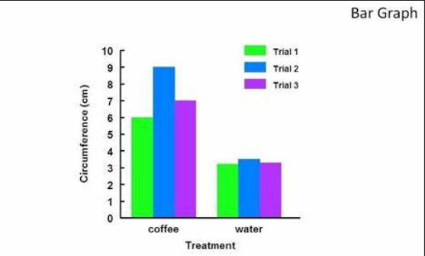

**Conclusion:** The hypothesis was correct; light is crucial for plant growth. Future experiments could explore different light colors.

**Tuesday: March 18**

1. **Complete the assignment from March 17th (Read & follow instructions)**
   1. **Ask for assistance within the first 10 minutes of class if needed**
2. **Work on Missing Assignments that have not been turned in use my teacher’s page and/or Canvas**

**Monday March 17th**

**Learning Target:** I can research and evaluate barriers to plant growth and sustainability and make the adjustments on improving the success of plant growth

Success Criteria:

1. I can evaluate the status of my plant’s health and hypothesize using evidence at least two factors that contributed to the current status of my plant
2. I can create a action plan to ensure the future success of the plants that I care for in the future using detailed steps that someone else could follow without my guidance but by reading my instructions.

**Classwork: Complete this in Canvas**

1. **List at least four observation you notice of your plant (what do you see when you look at it?)**
2. **Based on your observation is your plant healthy or unhealthy**
3. **List at least two factors that contributed to the current health of your plant**
4. **Research science experiences you could perform with the gardening and horticulture project (use links provided for assistance)**

**Links:** [**https://www.thoughtco.com/plant-project-ideas-373334**](https://www.thoughtco.com/plant-project-ideas-373334)

[**https://www.sciencebuddies.org/science-fair-projects/science-projects/experiment-with-plant-growth**](https://www.sciencebuddies.org/science-fair-projects/science-projects/experiment-with-plant-growth)

[**https://www.inspiritai.com/blogs/ai-blog/20-plant-science-fair-projects**](https://www.inspiritai.com/blogs/ai-blog/20-plant-science-fair-projects)

* 1. **Come inform your Coach to determine whether or not we have the resources to perform the experiment of your choice (WHEN APPROVED BY COACH, COMPLETE THE REMAINDER)**
  2. **Determine the questions you could pose based on the experiment you are interested in**
  3. **Create your hypothesis based on your research on the outcome of your experiment will present**

1. **Upload to Canvas**

**Week 10: March 11-14**

**Friday: March 14**

1. **2nd period: Sticky note**
   1. **Get your plant**
   2. **Determine who else in the class has the same plant as you (you will have to talk to one another**
   3. **On a sticky note (one per same seed)**
      1. **Write the name of each person**
      2. **Write the name of the seed**
      3. **Write each person’s name or have them write their name**
      4. **Upload to padlet and give sticky note to Coach Thomas**
2. **Turn in notebook with completed assignments**
3. **4th period: Complete work and turn in notebook to Coach Thomas**

**Thursday: March 13th:**

**Using the same partner/team members as the previous week when we did the Garden Design, write your name next to your group from below & come inform Coach Thomas, then in your notebook complete the following**

1. **Technology Group**  
   Focus: Set up and maintain technology for the project, such as automated watering systems, garden sensors (for soil moisture, temperature, etc.), and create a website or app to track the garden’s progress.
2. **Mowing and Lawn Care Team**  
   Focus: Mow the lawn, edge the borders, and maintain the grass to keep the area neat and prevent overgrowth.
3. **Weeding and Plant Care Team**  
   Focus: Remove weeds, plant, and maintain garden beds, ensuring that the right plants are in the right areas and are being properly cared for.
4. **Trash and Recycling Team 2 per class**  
   Focus: Clean up the area by collecting and disposing of trash, recycling any materials, and ensuring that the space remains free from litter and debris.
5. **Flower Bed Clean Out** Using materials provided, clean out flower beds
6. **Tool and Equipment Management Team**  
   Focus: Organize and maintain tools and equipment, ensuring they are ready for use. This team can also handle tool inventory and storage.
7. **Safety and First Aid Team**  
   Focus: Ensure safety protocols are in place for all activities, handle first aid if needed, and educate other students on proper gardening safety.
8. **Marketing and Documentation Team**  
   Focus: Document the garden’s progress through photos, videos, and written reports. Create promotional materials to share the project with the school community and perhaps the wider public.
9. **Recording/Scribing Group**: take notes according to coaches’ information based on notes
10. Engineering/Building Crew: using the instructions provided, assemble item provided by Coach Thomas

**Garden Area Cleaning & Setup Crew**

* 1. **Write the group assigned/chosen**
  2. **Write a brief description of your job based on what is listed next to your group**
  3. **List the materials needed**
  4. **Once completed, write a four-sentence description of your experience and how you can benefit from today’s experience in the Horticulture/Garden Project**
  5. **What would you change about what you did today? (not completing the task is not an option)**

**Wednesday: March 12th**

1. **Today is makeup day: List each and next to each if they are completed and turn in according to directions put a check mark next to it: if not, put an X then, complete the assignments and follow the proper directions for turning in** 
   1. **Use today to catch up on assignments from last week & yesterday**
   2. **What should be completed (Complete and turn in to CANVAS)**
      1. **KIM chart: emotional & mental health & summary**
      2. **Black History Project**
      3. **Care Card for Seed**
      4. **Garden Area Observations & Garden Bed Design (with partner but you should have your own completed)**
      5. **Steps for Preparing Garden Beds**
      6. **Plant Update & Care**

**\*\*USE TEACHER’S PAGE & RESOURCES TO COMPLETE AND FIND DIRECTIONS\*\*\***

**Tuesday: March 11**

1. **Plant Update & Care: Complete in Classwork Section of your notebook page 7 or 8**
2. **Come take picture of your plant and make observations and record the health of your plant based on the following (be sure to list the factor along with what you observe next to your factor so that it is clear what you are providing information about)**
   1. **What the seed you planted?**
   2. **Has your seed sprouted? If your plant has not sprouted you will still answer the questions based on what you should see once it does sprout or when you replant**
   3. **Color: What color is your plant? What are some color that would indicate concerns (if it is green provide an adjective for the type of green)**
   4. **Texture: Are/is there any wilting, drooping or excessive wrinkles?**
   5. **Stem-what observations do you see with the stem (or should you observe): list at least two**
   6. **Pest: Are there any signs of pest?**
   7. **Pest: List at least two indicators of the pest.**
   8. **Disease: List at least four signs of disease for plants and what the type of infection could be based on the sign (so you would write the sign and next to it the disease)**
3. **Next Steps:**
   1. **Describe using at least two complete sentences the overall health of your plant. If you do not have a plant explain why in at least two complete sentences**
   2. **How can you determine if your plant is getting enough water?**
   3. **How can you determine if your plant is getting too much water?**
   4. **What is the best temperature for your plant?**
   5. **Based on your research, list at least three things you need to do starting today to improve and/or maintain the health of your plant.**
4. **Show Coach Thomas**
5. **Upload**

**Example**

**Heading: Plant Update & Care 3/11/24**

1. **A: seed- tulip**

**B: My seed has not sprouted**

**C.Color: luscious green: if the plant was blue that would indicate poison**

**D.Texture:**

**Monday: March 10-Asynchronous: Complete missing work**

**Week 9: March 3-7**

**Friday: March 8, 2025**

1. **Work on assignments from the week that you have not completed**

**Thursday March 7, 2025 (In your notebook on page 7)**

1. **Watch video:** [**https://www.youtube.com/watch?v=Ahsmb0Rp4pU**](https://www.youtube.com/watch?v=Ahsmb0Rp4pU) **and list steps for preparing your garden bed in your steps make sure you include the following**
   1. **Heading: STEPS FOR PREPARING GARDEN BED**
   2. **The specific items and benefits**
   3. **About how much**
   4. **Exactly/specifically for each item, where can you locate them around the school**

**Wednesday: Asynchronous: 3/5/26**

**What a GREAT DAY TO CATCH UP ON ASSIGNMENTS YOU HAVE NOT COMPLETED**

1. **Go infinite Campus & write the name of the assignment for all assignments you have a 50 or below on**
2. **Next to each assignment write the grade you earned**
3. **Use this same document to locate the instructions for the assignment and complete the work. Many of the assignment can no longer be uploaded to Canvas so you will have to email**
4. **Assignments to focus on** 
   1. **CTB Video**
   2. **CTB Vision Board**
   3. **Black History Project**
   4. **Mental Health KIM chart & video summary**

**Monday March 3, 2025**

**Do Now: 3/3/25**

1. **Research companion plants for the seed you plant and their benefits**
2. **Add at least two companion plants to your health card along with the specific benefits of each**

**Classwork: 3/3/25: You have plenty of time to complete this today so it is due TODAY -ASK QUESTIONS EARLY IF YOU NEED ASSISTANCE**

1. **Garden Area Visit- Observations in your notebook on the 6th page** 
   1. evaluate sunlight exposure, wind patterns, and space for potential garden beds. (take notes of your observation of each)
      1. sunlight exposure
      2. wind patterns
      3. space for potential garden beds
      4. take measurement using your own feet or technology devices
2. **Individually or in pairs but in your own notebook**
   1. design a layout for a garden bed, considering plant compatibility, spacing, and optimal location (e.g., southern exposure, well-drained soil).: SKETCH IT OUT INCLUDING THE DIMENSIONS/MEASUREMENTS
   2. Include the following
      1. Location of garden beds (based on bed dimensions or space)
      2. What plants would you plant in your garden bed based on what you already planted and the companion research along with other items you are interested in the planting (school appropriate)
      3. The distance from each plant (do this for the same plants & the different plants)
         1. You should have at least five different plants
         2. Example: herb garden bed, flowers (marigolds, tulips, roses, daffodils)
      4. You must be able to justify why your plants will thrive based on the items you chose
      5. Design your irrigation system (how will you ensure your plants get the needed water when you are not present?)
3. **Turn in your notebook**

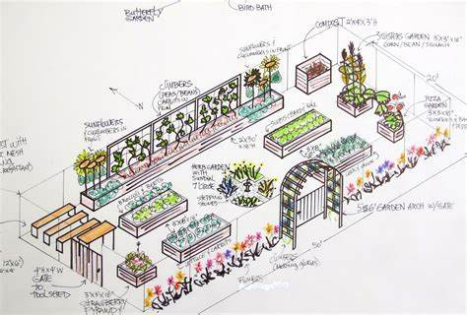

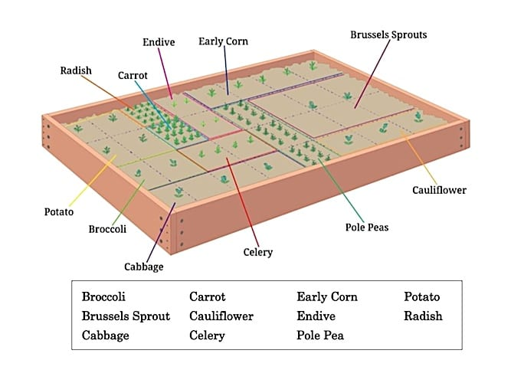

**Week 8: F/eb 24-28**

**Feb 28, 2025**

1. **Complete care of plant & take picture**
   1. **Water**
   2. **Determine if needs to go into bigger container**
   3. **Does it have enough sunlight/light?**
   4. **Fertilizer based on instructions**
      1. **(Coach will assist with this so do not pour any fertilizer until given instruction to do so)**
2. **Complete Black History Project** 
   1. **Remember to be creative with your delivery and include all required items**

**Feb 27, 2025**

**Do Now: 2/27/25**

1. **Come to Coach Thomas & follow directions for planting seeds if you do not have a plant already**
2. **Create a care card using the Index card provided and it should be based on the seed that you planted: This will be used for you to ensure you are doing everything possible for your plant to thrive. Include the following with labels or images as shown in the example (8 items total):**
   1. **Your Name**
   2. **Your seed/plant**
   3. **Date planted:**
   4. **How often to fertilize and how much?**
   5. **How much waters/how often:**
   6. **Best container/location to plant:**
   7. **How much sunlight?:**
   8. **Caution tips:**
   9. **When to transplant?**

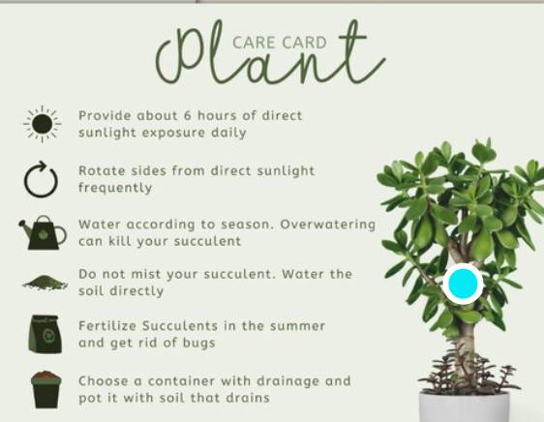

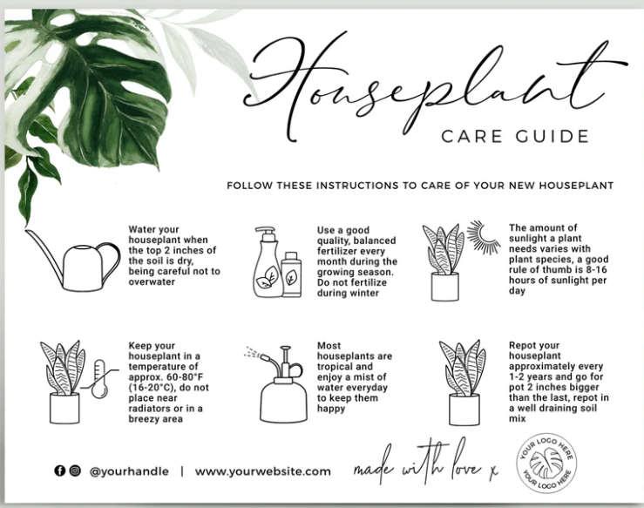

1. **Take a picture and upload on the padlet then turn in your care card to Coach Thomas**
2. **Find your plant, determine and do what needs to be done based on your observation**
   1. **Water**
   2. **Measure and see if it needs to be relocated to a bigger container**
   3. **If it has not grown check the care card and see if you need to do another one**

**Feb 25 & 26: Tuesday & Wednesday**

**Learning Target & success Criteria**

**I can explain how specific African Americans have contributed to mental health awareness and services.**

**I can describe how their work continues to influence society today.**

**Classwork:**

1. **Using the information below along with your own research choose which African American figure you want to highlight**
2. **Choose the method in which you believe you will complete your assignment based on the options:** 
   1. **Scrapbook Page – Handwritten or digital with photos, quotes, and a short biography.**
   2. **Digital Presentation – Canva, Google Slides, or video project. (No PowerPoints)**
   3. **Podcast Episode – Students record a short segment discussing the person’s impact.**
3. **Research and answer the following based on your figure**
   1. **Which health related topic did your figure impact : mental health, emotional health, and/or positive thinking**
   2. **List at least three ways in which your figure impacted the health area mentioned above**
   3. **Explain how these contributions have made a positive impact on the society/community (be specific based on what the person has done)**
   4. **How has your person paved the way for others?**
   5. **Explain in at least 5 complete sentences, how you can use this information in your own life.**
4. **Post your information in Canvas**

**Figures to Highlight: You can also choose someone who is not on this list if you would like and they have impacted these aspects of health**

**Bebe Moore Campbell – Advocate for mental health awareness and co-founder of NAMI Urban Los Angeles.**

**Dr. Joy DeGruy – Researcher on intergenerational trauma in African American communities.**

**Dr. Sidney Hankerson – Works to integrate mental health services in Black churches.**

**Maya Angelou – Poet and speaker on self-worth and positivity.**

**Oprah Winfrey – Media mogul and advocate for personal growth.**

**Dr. Martin Luther King Jr. – Used resilience and optimism in the Civil Rights Movement.**

**Feb 24: Monday**

**Do Now: 2/24/2025**

* 1. **Plant seed & upload response & image of seed into padlet using the link below (POST in the under the correct class period)**
     1. [**https://padlet.com/thomada/documenting-plant-growth-over-time-6j1w9k4wdsoq8029**](https://padlet.com/thomada/documenting-plant-growth-over-time-6j1w9k4wdsoq8029)
  2. **If you do not have a plant, come to Coach Thomas & get your materials to do so**

**Classwork: 2/24/2025**

1. **Stigma of African Americans and Mental Health**

[Snapping the Chain: Ending Mental Health Stigma in the African American Community](https://www.youtube.com/watch?v=ZcqtFlLNSa4)

[**https://www.youtube.com/watch?v=ZcqtFlLNSa4**](https://www.youtube.com/watch?v=ZcqtFlLNSa4)

1. **Interrupting the Stigma Video**

[**https://www.youtube.com/watch?v=gRtBe_1zyuA**](https://www.youtube.com/watch?v=gRtBe_1zyuA)

1. **On page 5 or 6 of your notebook, complete the following**
   1. **write a one-paragraph reflection in at least 5 complete sentences on what mental and emotional health means to them.**

**Week 7: Feb 19-21**

**Friday: Feb 21**

1. **Do Now: Complete any missing assignments: ASSIGNMENTS below will not be accepted after today (since these assignments are old and should be complete by now you will need to use my teacher’s page for guidance)**
   1. Pre-survey choosing the best
   2. CTB Lessons 1-4 Video
   3. CTB Lessons 5-8 Vision Board
   4. Post Survey Choosing the Best (Journey)
2. If you have completed a-d complete the following
   1. KIM chart & video summary (in notebook using instructions from 2/20/25
   2. Plant seed & upload response & image of seed into padlet using the link below (POST in the under the correct class period)
      1. <https://padlet.com/thomada/documenting-plant-growth-over-time-6j1w9k4wdsoq8029>

**Thursday Feb 20:**

Classwork: 2/20/25

1. Choose a partner or as an individual
2. Come to Coach Thomas to get an item to unbox and setup
   1. Follow the instructions and/or use teamwork to complete
   2. Raise your hand when you feel you are done
   3. Throw items in trash according to coach’s instruction
3. Create a KIM chart for mental & emotional health in your notebook on 4th page in your notebook (using your own words do not simply copy the definition from the textbook or internet; read the definition and pull out 3 key terms to help you define the word and list them in the information section with bullet points to the side; the memory clue section can be an image to help you define the term just by looking at it)

|  |  |  |
| --- | --- | --- |
| K. Key Term | I. Information Section | M. Memory Clue |
| Emotional health | * 1 * 2 * 3 |  |
| Mental health | * 1 * 2 * 3 |  |
|  |  |  |

1. Mental & Emotional Health Video -This should be completed under you KIM chart using this heading
   1. <https://www.youtube.com/watch?v=tY8NY6CMDFA>

Using the link above, watch the video & write 5 sentence summary explaining the importance of mental health and how emotional health is related to mental health.

1. Coach will allow those that did not plant seeds to do so & others will be called to take picture of planted seed & Post using the Prompt on padlet and be sure to include your name to receive credit
   1. <https://padlet.com/thomada/documenting-plant-growth-over-time-6j1w9k4wdsoq8029>

**Wednesday Feb 19:**

Do Now & Classwork: 2/19/25

1. Complete CTB Post Survey using Launchpad
   1. CTB2425
2. students allowed to work on Vision Board and any missing assignments

***Week 6: Feb 10-14***

Thursday Feb 13

1. **Students choose seed to plant**
2. **Write name and name of seed on label**
3. **Place soil in container, place three holes into soil using instructions on seed label**
4. **Give seed packet to coach so that you can be given the seed to plant in the soil**
5. **Place seeds in holes lightly cover with soil**
6. **Water & Place label in your container**

**Tuesday Feb 11-13**

***Do Now & Classwork: 2/11-13-Students allowed to work on missing assignments which all should be complete by 2/13/25***

1. Complete Vision Board
2. Complete Choosing the Best Exit Survey

**Monday Feb 10**

**Do Now & Classwork-**

1. From Launchpad to Choosing the Best:
   1. Go Lessons 5-8 in Choosing the Best then complete the Exit Survey
2. Complete Vision Board using word document in Landscape Layout
   1. Copy, cut, and paste your information based on your SMART goal and the information in manual by following the rubric (there is an example provided as well below for you to reference)
   2. YOU can use another platform such as Canva, but make sure your final product is similar to the example and all on one page

**Week 5: Feb 3-7**

**Friday 2/7**

Do Now: Complete any assignments from this week that you have not done in the order that they were assigned

1. Entry Survey following steps from teacher’s page and using Choosing the Best in Launchpad (Journey)
2. SMART goal (3rd page in notebook)
3. Baby Budget upload in Canvas
4. CTB Lesson 1-4 Video (using rubric & manual information provided)
5. CTB Lesson 5-8 Vision Board (using rubric, example, and manual information)

**Thursday 2/6**

Do Now: Review the requirements from the Video rubric from yesterday (see below this). Write any notes/outlines you will need to complete your video

Classwork:

1. Complete Choosing the Best Video Assignment using the information from your CTB Manual by going to Launchpad and accessing the icon/link
2. Ask questions before time is up if you need assistance
3. Begin working on Vision Board One pager using rubric, example provided, and information from manual (REMEMBER the rubric will be used to score your assignment)

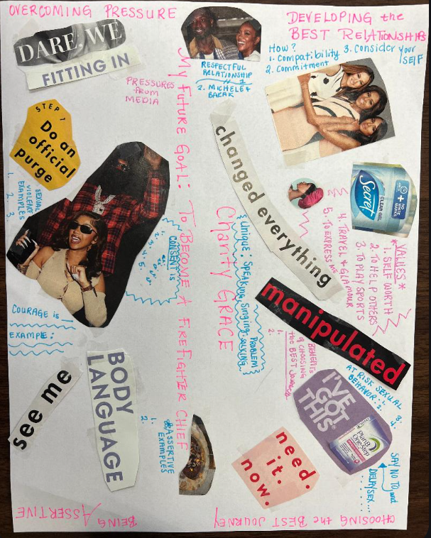

|  |  |  |
| --- | --- | --- |
| ***Choosing the Best Lesson 5-8 Vision Board One pager Assignment*** | | |
|  | ***Possible Points*** | ***Points Earned*** |
| 1. Include your future SMART goal (should be outline like the example provided) | ***20*** |  |
| 1. Developing the Best Relationships: how to develop best relationships (cover at least 3 of the five from page 36), what are your 5 personal values from the “What is Really Important to You list on page 38? How are you unique: 3 ways from page 38 list ? How will you demonstrate self-respect | ***20*** |  |
| 1. Choosing the Best Journey: what is the best journey according to the text? 4 At-risk sexual behavior to avoid, 2 benefits of choosing the best journey, the purpose of dating | ***20*** |  |
| 1. Overcoming Pressure: example of how the media and social media pressure individuals to have sex, steps for overcoming pressure, 3 example of sexual violence, What is Consent: 5 terms from page 56 and one word definition for each, identify two examples of a respectful relationship portrayed in the media (television, movies, social media, etc.) | ***20*** |  |
| 1. Being Assertive: 2 examples of assertive, courage defined and examples of how you can be courageous amongst your friends and explain why this will be considered courageous? | ***20*** |  |
| 1. You should have at least 10 images/cut outs and 1-5 should be easily identified with headings (Be prepared to present and/or explain your vision board as it relates to your goal and the information in the rubric | ***50*** |  |
| Total | ***150*** |  |

***Wednesday 2/5***

**Do Now: Complete the Baby Budget from Tuesday (refer to information/instructions below)**

**Classwork:**

1. **Using your rubric and the Choosing the Best Manual begin working on your video**
   1. **You can be creative and do a skit or an informative video but make sure it includes all of the components from the rubric-This should be completed and turned in by Thursday 2/6/25**
   2. **You will have another assignment to complete so do not wait until the last minute**

|  |  |  |
| --- | --- | --- |
| ***Choosing the Best Video Assignment: Lessons 1-4*** | | |
| ***Criteria/Requirement: Title*** | ***Possible Points*** |  |
| 1. Set/create SMART personal goal you desire for your future  a. Picture It | 25 |  |
| 2. Making the Best Decision  a. Barriers (2-3 possible barriers you could encounter while working towards meeting your goal)  b. List the steps for Decision Making Process using an example  c. Vocab: wisdom (how can you use this to make the best decisions) | 25 |  |
| 3. Avoiding Pregnancy  a. budget for a baby outline (review assignment completed in class to inform viewer of the cost of a baby)  b. Best method for reducing risk (100% and what that means) | 25 |  |
| 4. Avoiding STDs  -List four from text provided  -compare and contrast condoms, birth control, and abstinence  -Vocab: Honesty-How will honesty assist you will avoiding STDs | 25 |  |
| ***Total*** | ***100*** |  |

***Tuesday 2/4/24***

Do Now: Go to Lauchpad and Choosing the Best

1. Complete your SMART goal from yesterday
2. Click on the eye to view your manual and go to page 22 (A Budget for a Baby)

Classwork:

A.

1. Based on your goal and your dream job, research how much you would make hourly, weekly, and/or monthly: record that in your chart in the textbook
2. Using the following information calculate how much will be taken out of your income for taxes
   1. State: about 5%
   2. Federal: 12 %
3. Follow the remainder of the chart on page 22 and fill it in using researched information
4. Complete your calculations
5. Screenshot your budget when you are done & upload in Canvas

B.

1. Use the CTB manual to research STDs and how they spread & complete the research for number four and begin working on your video to upload into Canvas: Follow the rubric

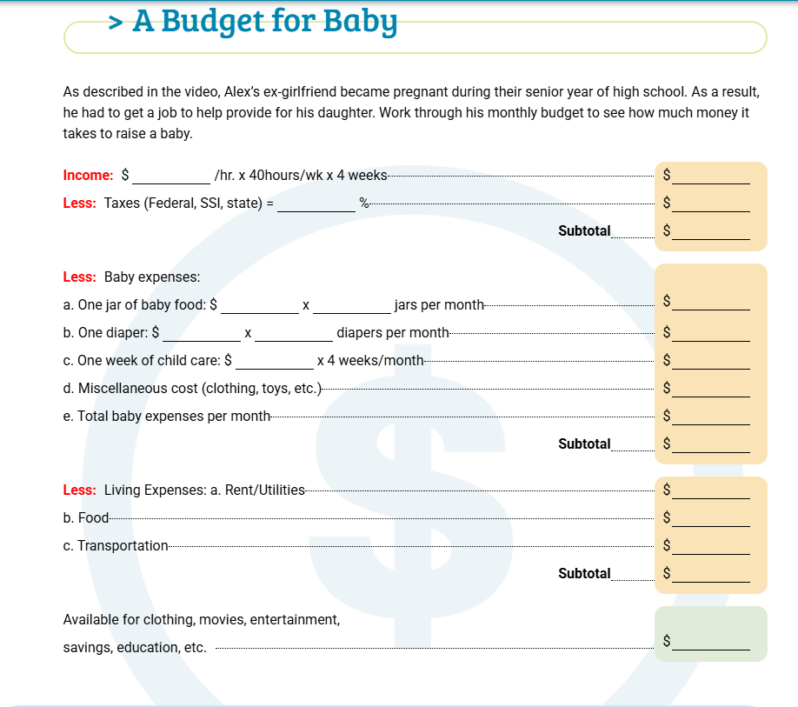

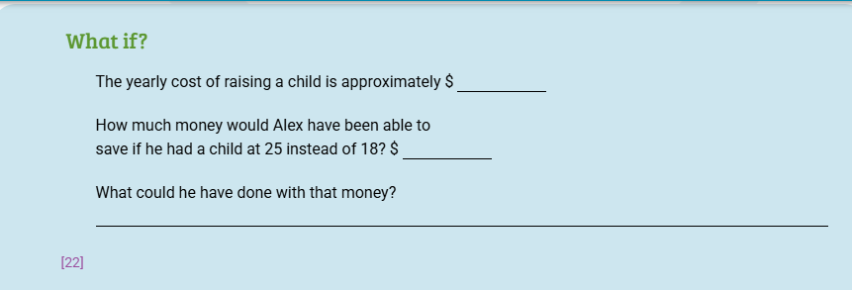

***Monday Do Now: 2/3/25***

1. ***Get out your computer and go to Launchpad***
2. ***Fine the Choosing the Best Link***
3. ***Use the following code to complete the survey:* CTB2425 or CTB2025**

**Classwork: Think of what you want to accomplish within the next 5-10 years (REALISTICALLY)**

1. **On the third sheet of your notebook complete the following using the example provided, you should have SMART goal as your heading, list 1-5 along with the bold term and the information that corresponds with YOUR specific goal.**

**Description and Example of a S.M.A.R.T. Goal:**

1. **Specific:** The goal should be clear and specific, answering the questions of what, why, and how.
   * Example: "I want to run a 5K race."
   * Example: I want to get my Associate’s Degree and work at a hair salon
2. **Measurable:** The goal should be measurable, allowing progress to be tracked and assessed.
   * Example: "I will track my running distance and time using a running app."
   * I will apply to three school by the end of my junior year
3. **Achievable:** The goal should be realistic and attainable, considering the individual's current fitness level.
   * Example: "I will gradually increase my running distance by 0.5 miles each week."
   * I will research entry requirements to get into the Associate’s program and the duties of a hair stylist by the end of my junior year
4. **Relevant:** The goal should be relevant to the individual's overall fitness objectives and aligned with their values.
   * Example: "Running a 5K will improve my cardiovascular health and help me stay active."
   * I love to do hair and want to spend my life doing this
5. **Time-Bound:** The goal should have a specific deadline or timeframe.
   * Example: "I will run a 5K race within 3 months."
   * I will accomplish this within the next 5 years

**Complete S.M.A.R.T. Goal Example:** "I want to run a 5K race (Specific). I will track my running distance and time using a running app (Measurable). I will gradually increase my running distance by 0.5 miles each week (Achievable). Running a 5K will improve my cardiovascular health and help me stay active (Relevant). I will run a 5K race within 3 months (Time-Bound).

|  |  |  |
| --- | --- | --- |
| ***Choosing the Best Video Assignment: Lessons 1-4*** | | |
| ***Criteria/Requirement: Title*** | ***Possible Points*** |  |
| 1. Set/create SMART personal goal you desire for your future  a. Picture It | 25 |  |
| 2. Making the Best Decision  a. Barriers (2-3 possible barriers you could encounter while working towards meeting your goal)  b. List the steps for Decision Making Process using an example  c. Vocab: wisdom (how can you use this to make the best decisions) | 25 |  |
| 3. Avoiding Pregnancy  a. budget for a baby outline (review assignment completed in class to inform viewer of the cost of a baby)  b. Best method for reducing risk (100% and what that means) | 25 |  |
| 4. Avoiding STDs  -List four from text provided  -compare and contrast condoms, birth control, and abstinence  -Vocab: Honesty-How will honesty assist you will avoiding STDs | 25 |  |
| ***Total*** | ***100*** |  |

|  |  |  |
| --- | --- | --- |
| ***Choosing the Best Lesson 5-8 Vision Board One pager Assignment*** | | |
|  | ***Possible Points*** | ***Points Earned*** |
| 1. Include your future SMART goal (should be outline like the example provided) | ***20*** |  |
| 1. Developing the Best Relationships: how to develop best relationships (cover at least 3 of the five from page 36), what are your 5 personal values from the “What is Really Important to You list on page 38? How are you unique: 3 ways from page 38 list ? How will you demonstrate self-respect | ***20*** |  |
| 1. Choosing the Best Journey: what is the best journey according to the text? 4 At-risk sexual behavior to avoid, 2 benefits of choosing the best journey, the purpose of dating | ***20*** |  |
| 1. Overcoming Pressure: example of how the media and social media pressure individuals to have sex, steps for overcoming pressure, 3 example of sexual violence, What is Consent: 5 terms from page 56 and one word definition for each, identify two examples of a respectful relationship portrayed in the media (television, movies, social media, etc.) | ***20*** |  |
| 1. Being Assertive: 2 examples of assertive, courage defined and examples of how you can be courageous amongst your friends and explain why this will be considered courageous? | ***20*** |  |
| 1. You should have at least 10 images/cut outs and 1-5 should be easily identified with headings (Be prepared to present and/or explain your vision board as it relates to your goal and the information in the rubric | ***50*** |  |
| Total | ***150*** |  |

***Week 4: Jan. 27- 31***

***Do Now: 1/29/25 & 1/30/25 & 1/31/25***

1. **Get out a sheet of paper**
2. **Write your name, date, class period on top line**
3. **List assignments & due date**
   1. **Group Project**
   2. **ADAP brochure**
   3. **ADAP Assessment**
   4. **Notebook (turn in with name & period)**
4. **Next to each assignment, write your grade**
5. **Explain why you were or were not able to complete the assignment according to expectations. How will you continue to do well or do better moving forward**

**Classwork: 1/29/25**

1. **Complete missing work**
2. **Walk and/or Volleyball**

***1/28/25***

Same as Previous Day-

1. Students provided time to makeup assignments
2. Coach call students to review grade report summary as of now & given opportunity to ask questions

**1/27/25**

**Do Now:1/27/25**

1. **Complete Asynchronous Assignment**
2. **Prepare for your presentation:**
   1. **Pull up your PPT and review**
   2. **Get out your poster, brochure, pamphlet**
   3. **Upload it into Canvas if you have not done so**

**Classwork: 1/27/25**

1. **Progress checklist-assignments & score**
2. **Today I will**
3. **To overcome excuses/obstacles, I will**
4. **I should have a notebook as of today and loose paper will not be accepted from here forward unless that is the assignment**
   1. **Padlet login- Make sure you post under your class period & include your name** 
      1. **2nd period:**
         1. [**https://richmondcountyschool.padlet.org/thomada5/breakout-link/kxPM2kxVxJg6qgbV-BjRPz6NkReMezQGg**](https://richmondcountyschool.padlet.org/thomada5/breakout-link/kxPM2kxVxJg6qgbV-BjRPz6NkReMezQGg)
      2. **4th period:**
         1. [**https://richmondcountyschool.padlet.org/thomada5/breakout-link/6RDZ2yBlBR9Yqyej-BjRPz6NkReMezQGg**](https://richmondcountyschool.padlet.org/thomada5/breakout-link/6RDZ2yBlBR9Yqyej-BjRPz6NkReMezQGg)
   2. **Complete prompt**
   3. **Work on missing assignments (none accepted after 1/31/25 from first three weeks)**
5. **Students will present based on option chosen**
   1. **Those not presenting will complete peer presentation guide/feedback**
6. **Students work on missing assignments**

**1/ /25**

**Do Now: 1/2/25**

1. **Complete student reflection for first two week**
   1. **Course name**
   2. **How it helps toward graduation: required content or Elective**
   3. **List of assignments so far & grades for each & how much time provided to complete**
   4. **Current grade in class**
   5. **Accountable Steps moving forward to ensure credit is earned**

**Classwork: 1/22/25**

1. **ADAP remediation assignments and test redo**
2. **Notebook setup**

**1/23/25**

**Do Now: 1/23/25**

1. **Complete notebook setup from previous day if you did not do so already**

**Classwork: 1/23/25**

1. **Student that do not have notebooks will contact parents in class and check off with teacher on communication**
2. **Plant seeds if materials are available** 
   1. **Chart information: date planted, seed planted, & creating care card (facts of how to ensure optimal growth)**

**1/24/25**

**Do Now: 1/24/25**

1. **Complete notebook setup & turn in to coach for grade**

**Classwork: 1/24/25**

1. **Benefits of growing your own food for nutrition video**
   1. **Grocery store to tackle food desert issues**
      1. [**https://www.youtube.com/watch?v=p4BrajNx9Gk**](https://www.youtube.com/watch?v=p4BrajNx9Gk)
   2. **Turning food desert into opportunity**
      1. [**https://www.youtube.com/watch?v=k0msIib3WVU**](https://www.youtube.com/watch?v=k0msIib3WVU)
2. **Share & answer questions on padlet**

***Week 3: Jan 20-24 Asychronous***

**1/20/25:**



***1/21/25-1/24/25***

***Health, Asynchronous***

***Instructions: Use my teacher’s page (school website, staff & departments, Thomas, D., Health***

***2024-25 Assignments) just as we have been doing this entire semester to access the manual,***

***instruction, and rubric.***

***1. Complete your ADAP brochure according to the rubric & information in the PowerPoint***

***& ADAP manual***

***2. Get the last 4 digits of your social and login to the DDS website (the link is below) create***

***an account, login, and complete the ADAP assessment***

***a. You must use the information as it shows on your birth certificate***

***b. Your reason for enrollment: other***

***c. https://online.dds.ga.gov/eADAP/StudentRegistration.aspx***

***3. Screen shot your score including your name and the certificate earned***

***4. Upload the screenshot into Canvas***

***5. Work on any other missing assignments for the semester***

***a. Group project from week 1***

2.4 pg 57 Community & Public Health

***Week 2: Jan 13-17***

**1/13/25**

Do Now:1/13/25 - fold copy paper for brochure using guide from Coach

Classwork: Manual Review & Class Discussion for Ch. 1 & Students complete title page and Ch.1 portion of brochure.

*REMINDER: Upload your group assignment presentation into Canvas (EACH person)*

|  |  |  |
| --- | --- | --- |
| **ADAP Brochure Rubric** | | |
| **Information/Requirements**  **Use the manual my teacher’s page and/or Canvas to get the information and the rubric to complete the brochure.** | **Possible Points** | **Points Earned** |
| Title Page:  a.name & class period  b. Title of Brochure  c. Relevant Image | **20** |  |
| Ch. 1 Be sure to include  a. TADRA and what it represents  b .How did the implementation of TADRA impact teenage fatal crashes?  c. List & briefly describe each steps/level of license process  d. TADRA DUI suspensions:  -what is BAC?- reasons for suspension & what happens for suspensions 1-3 | **20** |  |
| Ch.2 Traffic Laws and Safe Driving  1.List 8 traffic laws  For each law provide the following”   1. brief description explaining why it is important to follow the law (what are the consequences? How) | **20** |  |
| Ch. 3   1. List the 11 types of drugs from the manual provided 2. For each drug   a. list at least three effects it has on the body  b.one interesting fact about the drug from the manual | **20** |  |
| Color, Creativity, at least 3 relevant images | **20** |  |
| **Total** | **100** |  |

**1/14/25**

Do Now:

1. Get out your ADAP brochure or come get a sheet of copy paper to begin your brochure
2. Use the rubric & check to make sure you have the required information for the title page & chapter 1
3. Complete any missing information for the title page & chapter 1
4. Use your computer or tablet to go to the ADAP manual

Classwork: 1/14/25

1. Coach lecture & class discussion on Ch. 2 traffic laws using DDS PPT & Manual
2. Students use remaining time to complete Ch. 2 portion of brochure

**1/15/25**

Do Now: 1/15/25

1. Get out your ADAP brochure or come get a sheet of copy paper to begin your brochure
2. Use the rubric & check to make sure you have the required information for the title page, chapter 1 & chapter 2
3. Complete any missing information for the title page, chapter 1 & chapter 2
4. Use your computer or tablet to go to the ADAP manual

Classwork: 1/15/25

1. Alcohol & drugs video
2. Class discussion on ADAP Ch. 3
3. Students complete Ch.3 of ADAP brochure using rubric & ADAP manual from teacher’s page and/or Canvas

**1/16/25**

Do Now: 1/16/25

1. Get out your ADAP brochure or come get a sheet of copy paper to begin your brochure
2. Use the rubric & check to make sure you have the required information for the title page, chapter 1, chapter 2, & Ch. 3
3. Complete any missing information for the title page, chapter 1, chapter 2, ch.3
4. Use your computer or tablet to go to the ADAP manual
5. Write down any questions you have about the completion of the ADAP brochure for the Coach

Classwork: 1/16/25

1. Use this time to finish your brochure
2. Ask question if you need assistance
3. Complete the checklist when you are done then turn in checklist and brochure when you are done

**1/17/25**

Do Now: 1/17/25

1. Turn in your checklist and brochure
2. Login to joinmyquiz.com for review

Classwork: 1/17/25

1. ADAP review using quizzziz

***Week 1: Jan 6-10***

***1/6/25***

Do Now: N/A

Classwork: Syllabus & Class Expectations Review, students assigned groups

**1/7/25**

Do Now: Take out computer & go to teacher’s page

Classwork: Coach reviewed expectations, how to access syllabus, explained group assignment & assigned groups (group members determined roles & were called and given opportunity to ask questions and receive help from coach) *{Instructions follow on this same document; students use textbook Ch. 1 & 2 along with instructions to complete assignment}*

**1/8/25**

Do Now: N/A

Classwork: Coach provided exemplar for project, reviewed expectations and called student to check status and see if assistance is needed

**1/9/25**

Do Now:

1. What is your group’s topic?
2. what is your responsibility in the group?
3. What form of presentation did your group choose?
4. Using numbers, which numbers are already included in your final project for presentation?

Classwork:

1. Students work on finishing project and upload in Canvas once completed (each person in the group will upload the project)-
2. Complete checklist (one per group)

**1/10/25**

Do Now: make sure your project is uploaded in Canvas (each person in group will upload)

Classwork: students complete presentation based on choice by group; those not presenting will complete feedback

**Directions: You will work in a group of four and will be assigned a main health topic to research and present to the class. You and your group members will present your information choosing which method works best for your group**

|  |
| --- |
| **Group Presentation Options** |
| 1. A. Video presentation (if this method is chosen, students will still need a final visual representation of their information which can be done as a poster, brochure, or pamphlet)   each person will present the portion they are responsible for and upload it to canvas |
| 1. B. PowerPoint (the PowerPoint should be visually appealing with students using creativity and images) 2. including the required information and each person will do a voice recording of their portion of the assignment |
| 1. C. In class presentation 2. (if this method is chosen, students will still need a final visual representation of their information which can be done as a poster, brochure, or pamphlet) each person will present their portion of the information to the class |

Each group should include the following

1. Highlighted key vocabulary terms within the section in KIM chart form (example below)

|  |  |  |
| --- | --- | --- |
| K. key term | I. information | M. Memory Clue |
| Science | The study of nature and society using experimentation, observation, and evidence | C:\Users\ThomaDa\AppData\Local\Microsoft\Windows\INetCache\Content.MSO\9C464D5C.tmp |

1. 5-7 sentence summary of entire section in own words
2. 3 important and/or interesting facts from each subheading red/burgundy section after your main (blue topic until you reach the next blue section or end of chapter)
3. 2 relevant Images AND 5 questions that one should be able to answer based on your group’s information

|  |  |  |  |  |  |  |
| --- | --- | --- | --- | --- | --- | --- |
| Topic | Group Members | Key vocabulary that should be included | Subheading | | Presentation Option Chosen | |
| 1. Dimensions of Health & Wellness | 2nd period  1.Jordon A.  2. Storie  3. Jayden  4. Brayan  4th period  Darius H  Tre Williams  Zion Walker  Makayla | Health  Well-being  Wellness  Physical health  Mental health  Emotional health  Social health | 1.Physcial health  2.Mental & Emotional Health  3.Social Health  4.Interaction of Health Dimensions | |  | |
| 1. The Continuum of Health | 2nd period  1.Edgar  2.Branden  3.Gekere  4.Travis  4th period  Elijah B  Brycen  Scott  J. Foster | 1.life expectancy  2.life span  3.quality of life  4.optimal health  5.illness | There are no subheadings so do the important facts for each paragraph (there are 4 paragraphs) | |  | |
| 1. Genetic Factors | 2nd period  Kiamora  Cassie  Cameron  4th period  Danielle  Maliyah HighSmit  Isaiah Thompson  Jada Ware | 1.risk factors  2.protective factors  3.genes  4.deoxyribonucleic acid  5.genetic disorders | 1.Weight  2.diseases and disorders  3.mental health conditions and illnesses | |  | |
| 1. Behavioral Factors | 2nd period  1.Miranda  2.Lakelin  3.Jasmine  4.Brielle  4th period  Nichi B  Janiya  Malyah H  Jamere Wright | 1.behavioral factors  (the individual responsible for this vocabulary section will be responsible for 4 & 5 of the subheading since there is only one vocabulary term in this sections) | 1.nutrition and physical health  2.sleep  3.tobacco, alcohol, and drug use  4.sexual activity  5.injuries and accidents | |  | |
| 1. Physical Environment | 2nd period  1.Legacy  3.Aleya  4th period  Ny’Aasia  Hannah  Lyric  Cassidy | 1.environment  2.geography  3.pollution  4.homelessness | 1.climate, geography, and pollution  2.Home, School, and work conditions | |  | |
| 1. Social Environment | 2nd period  1.Michael W  4th period  Michael B | 1.culture | 1.Family  2.peers  3.culture and community | |  | |
| 1. Media & Technology | 2nd period  1.Zi’Asia (1/9 first day)  4th period  1.Hiczania  2.Johnny  3. Unique  4.Jarquavious | 1.media | Since there are no subheadings, you will complete this sections for each paragraph. There are 3 paragraphs | |  | |
| 1. Economic Environment | 4th period  Ry’ana F  Mariah H. | 1.economic environment | 1.Education & Income  2. Access to Health Services | |  | |
| Chapter 2 | | | | | | |
| **Topic** | **Group Member & responsibility** | **Key vocabulary** | **subheadings** | |  | |
| 1. Making Healthy Decisions | **Ian Carr** | 1.decision making process  2.alternatives  3.collaborative decision making | 1.The Decision-making process  2.Collaborative Decision making | |  | |
| 1. Setting & Reaching Goals | **Damion Y.** | 1. Goals 2. Values 3. SMART goal | Since there are no subheadings, you will complete this sections for each paragraph. There are 3 main paragraphs | |  | |
| **Health & Wellness Ch.1 & 2 Group Project Rubric** | | | | | | |
| **Requirements/Weekly Assignments** | | | | **Possible Points** | | **Points Earned** |
| 1. Background Research (each member has their part on index card or sheet of paper from 1/7/25) | | | | 20 (5 points each) | | 20 |
| 1. Each component of the assignment present   a. Key Term  b. 5-7 sentence summary  c. important/interesting facts  d. 2 images & 5 questions and answers | | | | 40 (10 points each) | | 40 |
| 1. Presentations (each person verbally presents in PowerPoint and/or presents in video and/or in front of class) | | | | 40 (10 points each) | | 0 (no voice) |
| 1. Creativity, Color, Organization, and Structure | | | | 25 | | 25 |
| Total | | | | 125 | | 85 |

|  |  |  |  |
| --- | --- | --- | --- |
| **Weekly Assignment Requirements & Progress Tracking** | | | |
| Day | What should be done: | Student check | Teacher check/Comments |
| Day 1 | Group topic___________________________________  Name__________________________will do________  Name__________________________will do________  Name__________________________will do________  Name__________________________will do________ |  |  |
| Day 2 | 1.Complete your section on the index card or paper provided by coach & upload image into Canvas (ask for assistance when needed being prepared to share the resources used to gather /find information or instructions)  2. You can begin working on final project poster, brochure/pamphlet, recording, etc. |  |  |
| Day 3 | 1. Work with group members put final project together based on chosen presentation method should be at least 50% complete by the end of the class period |  |  |
|  |  |  |  |
| Day 4 | 1. Finish/Complete the entire assignment and presentation with each individual understanding their role within the group/team 2. Upload presentation into Canvas (all except in class presentation groups) |  |  |
| Day 5 | 1. Self-Check using assignment and presentation rubric (each person in the   group will do this individually in Canvas) |  |  |